

**WEB SITE OF**

**CAMBRIGDE HOSPITAL**

**group members**

|  |  |
| --- | --- |
| * Student1005999 | FARHAB ANSARI |
| * Student1002511 | MUHAMMAD SAAD ALI |
| * Student1006968 | MEHREEN SABA |
| * Student1006687 | MUHAMMAD UMAR HASAN KHAN HAFIZ |
| * Student1006322 | SYED MUHAMMAD MUZAMMIL ALI QAZI |

**Table of Contents**

* ACKNOWLEGDMENT
* PROJECT CERTIFICATION
* INTRODUCTION
* USER GUIDE
* SNAP SHOT OF WEB SITE
* FLOW CHART
* PLANNING
* USER REQUIRMENT



# ACKNOWLEDGEMENT

In the present world of competition there is a race of existence in which those are having will to come forward succeed. Project is like a bridge between theoretical and practical working. First of all we would like to thanks ALLAH SWT, The most merciful and most beneficent. Without his grace this project could not become a reality. It would not have been possible without the kind support and help of many individuals. We would like to extend our sincere thanks to all of them. We are highly indebted to Ms. Faiza Khan for her guidance and constant supervision as well as for providing necessary information regarding the project & also for their support in completing the project. Our thanks and appreciations also go to our colleague in developing the project and people who have willingly helped us out with their abilities.

# Project Certification

*This is to certify that,*

|  |  |
| --- | --- |
| * FARHAB ANSARI * MUHAMMAD SAAD ALI * MEHREEN SABA * MUHAMMAD UMAR HASAN KHAN HAFIZ * SYED MUHAMMED MUZAMMIL ALI QAZI |  |

*Successfully Designed & Developed* **“*Employee Record Management System”***

*Date of Issue:*

***1-Mar-2017***

***Date of Submitting***

***31-Mar-2017***

*Authorized Signature:* Miss Faiza

**Introduction Of**

**Cambridge hospital**

**We Have Created**

**Web Site**

**In Cambridge Hospital**

As a student of Aptech computer institute the E-project gives student a chance to practice all the knowledge and skills that they gain along the academic session in solving problems through a project in order to be an efficient and a good assistant engineer. This Web Site Is So Interesting Because This Web Site Available Services, Facilities, and Academic, Contact Us, About Us, Query, Success Stories, And Etc. This Web Site To All Information Available Suppose Them Information To Doctors, Emergences, Cancer And Etc. And Cambridge Hospital It’s To Good And The Doctors It’s So Intelligent Because This Hospital To All Services Available And This Web Site Is So Simple And User To Be Use More Easily. This Web Site Is Very Interesting.

**SERVICES OF**

**Cambridge Hospital**

**snap SHOT**

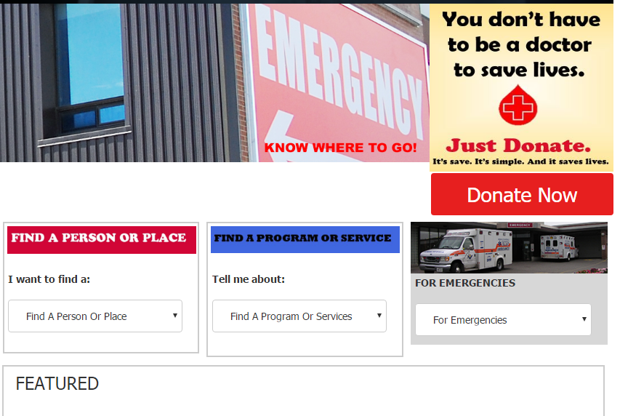

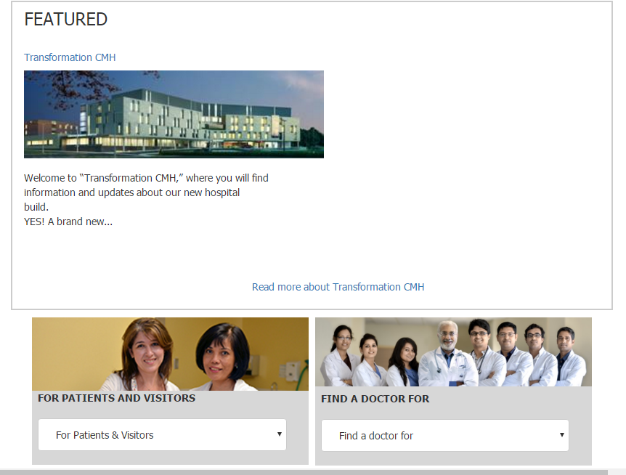

**user requirement**

1) The Home Page with some description about the Cambridge Hospital like who  
  
 is the founder and some of the achievements of handling critical cases.(Also  
  
 navigational link must be included.)  
  
 2) The website must provide information like “About us”, “Department”,  
  
 “Facility”, “Services”, “Centers”, “Academic”, “Contact Us”, “Vacancies”,  
  
 ”Query”, Feedback”, “Success Stories”.  
  
 3) Each section must provide brief information.  
  
 4) Also each link must be properly hyperlinked; images must be used wherever  
  
 necessary.  
  
 5) Contact us page must flash the address of all the location where the hospital  
  
 is located.  
  
 6) Department details like “helpdesk”, “registration”, “Doctor Schedule”, Billing  
  
 and Accounts” and so on must be included.  
  
 7) Facility like “rooms”, ICU”, Medical Facilit`5y”, “Other Facility”.  
  
 8) Services like “general services”, “Health Checkup”, “Specialties” and so on.  
  
 9) Centers like “diagnostic Centre”, “cancer Centre”, “heart Centre”, “community  
  
 health Centre”.  
  
 10) Feedback must be taken.  
  
 11) Query must be allowed to enter

**Describe Problems**

We didn’t get all material related are web site

* Didn’t get image of hospital.
* Time is to short.
* This web site is very tuff.

**Facility**

**Our Facility Includes**  
  
24-hour emergency medical care  
A full-time staff of US and UK board-certified physicians  
Visiting physicians from the US and UK  
Fully digital imaging center with nuclear medicine, mammography, CT, X-ray, MRI, and ultrasound  
12 state-of-the-art operating rooms and same day services center  
More than 25 Medical and Surgical specialties  
A staff of over 650 employees with over 100 consultant doctors  
Complete Pathology/Laboratory Services  
Comprehensive Orthopedic Services  
Complete Diagnostic and Therapeutic Radiology  
Complete Dialysis services with 16 dialysis machines  
Coronary Angiography / Angioplasty and Stent Placement  
Total body Angiography Complete – Diagnostic and Therapeutic

# LIST OF FACILITY:

* **OPD (Allopathy & Homeopathy):**  
  Patients are registered at the reception and are seen on first come, first serve basis, however out of turn consultation may be provided in case of emergency and senior citizen. Patients have the right to consult any doctor. In OPD, clinical consultation is provided to patients which includes history taking, clinical examination, diagnosis and providing prescription to patients besides advising laboratory tests in some cases. OPD has a waiting hall with chairs, a TV, public utilities like drinking water and toilets. Sub waiting areas are available in front of individual consultation rooms. Wheel chairs, trolleys and attendants are there to help very sick patients.
* **Ward/ Indoor facility:**  
  Ward facilities for observation and management of medical problem like typhoid, acute gastroenteritis, COPD, bronchial asthma, malaria, viral fever, pneumonias etc. There are 3 wards, one special room and one well equipped emergency.
* **Minor OT:**  
  Provides services for minor surgical procedure like dressing of lacerated wound, suturing of minor lacerations & resuturing, excision of corns and sebaceous cysts (done under local anesthesia.)
* **Physiotherapy:**  
  Range of physiotherapy services to assist the patients to recover from wide range of musculoskeletal pain-full disorders. Available modalities are MWD, SWD, U/S, TENS, IFC laser therapy traction unit, magnolia.
* **Laboratory services:**  
  Trained laboratory staff are providing best services which includes painless blood withdrawal Services of one NABL accredited laboratory are also available for carrying out specialized tests, they collect sample from 8 AM to 12 noon. In IIT Hospital.  
  Sample collection time for IIT laboratory is 8 am to 10.30 am while emergency tests like Blood sugar, platelet count & HB & blood grouping done in emergent cases throughout OPD hours.
* **ECG Services:**  
  24hours ECG services including machine report, done by trained staff.
* **Pharmacy:**  
  Free reliable quality medicines are available to beneficiaries on doctor prescription during OPD hours. Medicines not available are provided by S.O. signed by prescribing Doctor and Head and collected from on campus chemist shop.
* **Radiology/X-ray facility:**  
  X-Ray pleophos-D, 300 MA Siemens available, X-rays done on all working days during OPD hour. Sonoline G-50 U/S machine, Siemens. Ultrasounds are done once a week.
* **Ambulance Services:**  
  24 hours patient transport vehicle available. Patients are transported from home (on campus) to IIT hospital and patients referred by emergency duty doctor to empanelled hospital for specialized case.

**Snap Shot Of Logo**

**Cambridge Hospital**



**Snap Shot**

**Of Home Page**

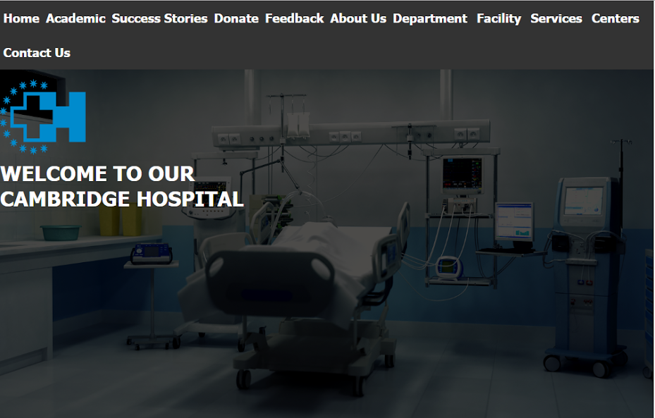

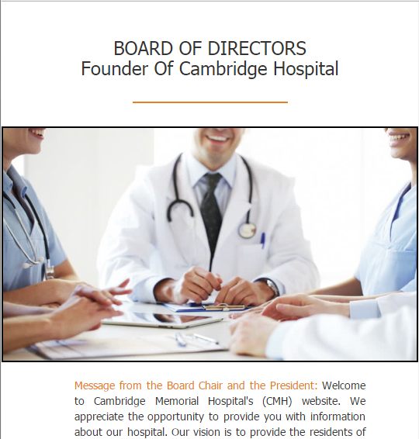

**Snap Shot**

**OF ACHIEVEMENT**

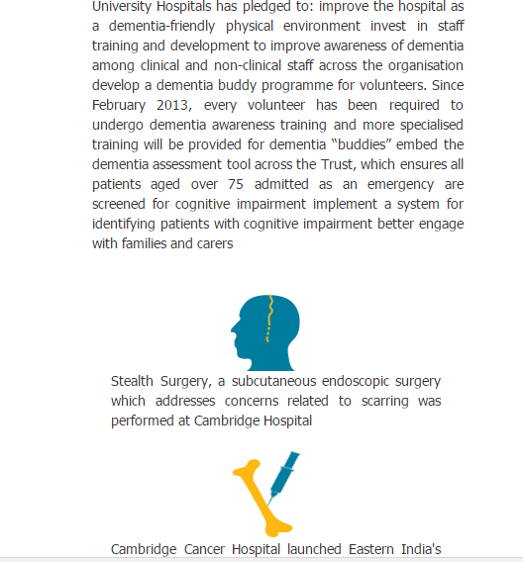

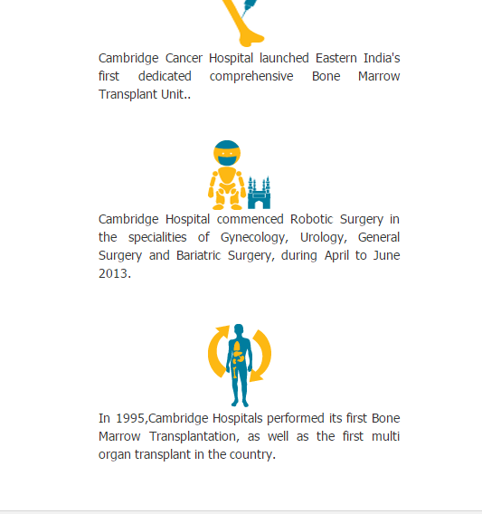

**SNAP SHOT**

**OF FOOTER**

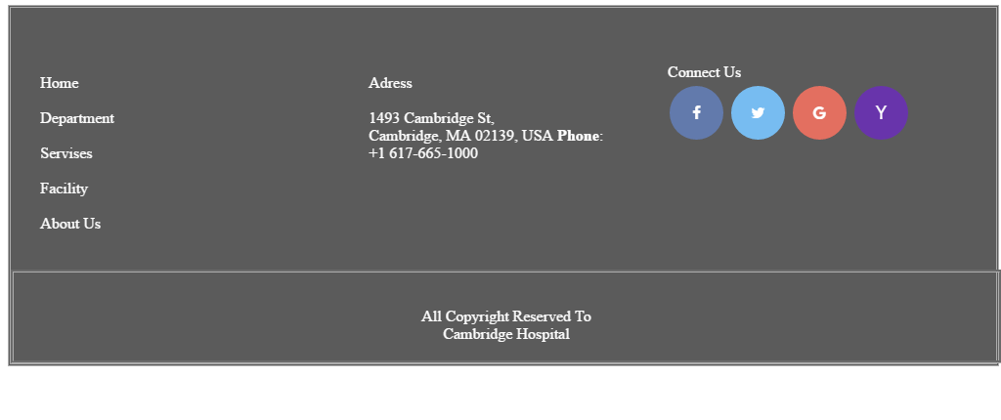

**SNAP SHOT**

**Of**

**Coding**

# Bootstrap Slider Coding:

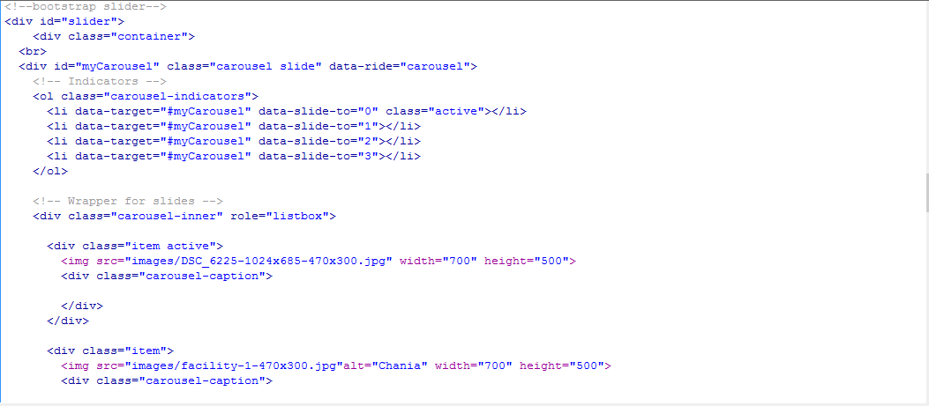

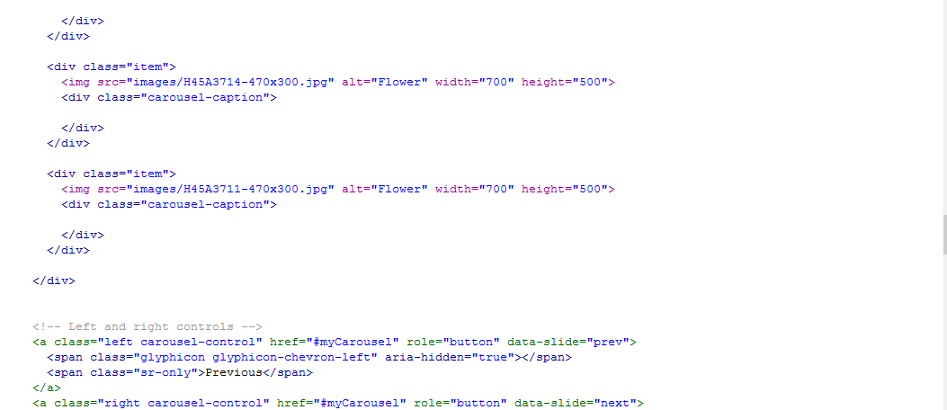

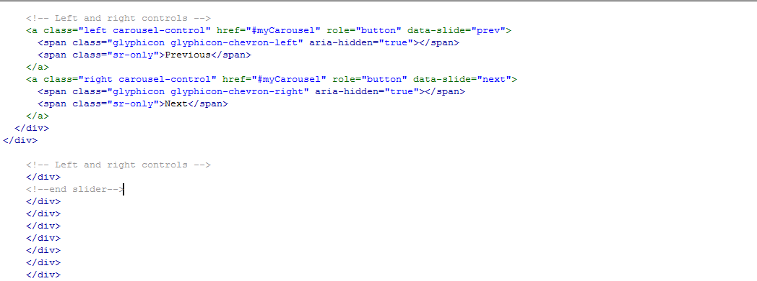

# Hover Slider Coding:

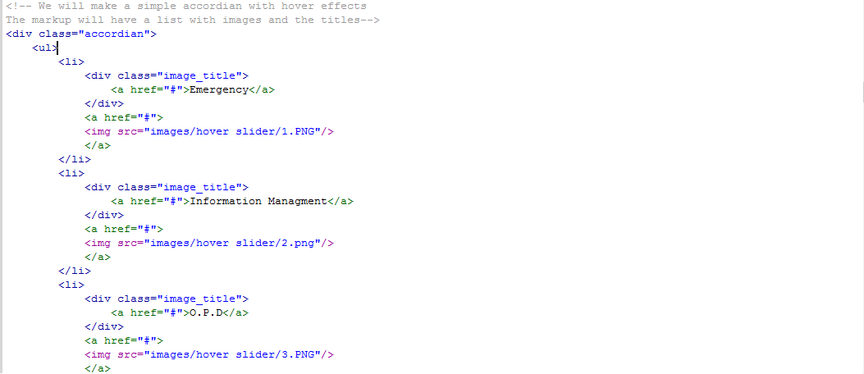

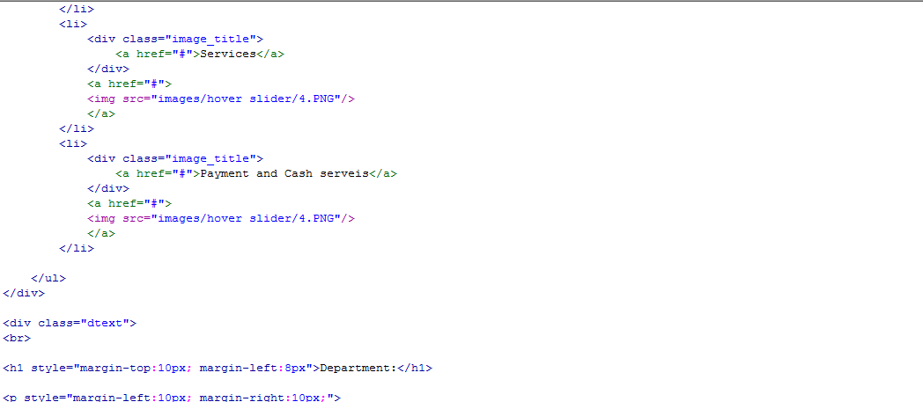

# CSS Slider Coding:

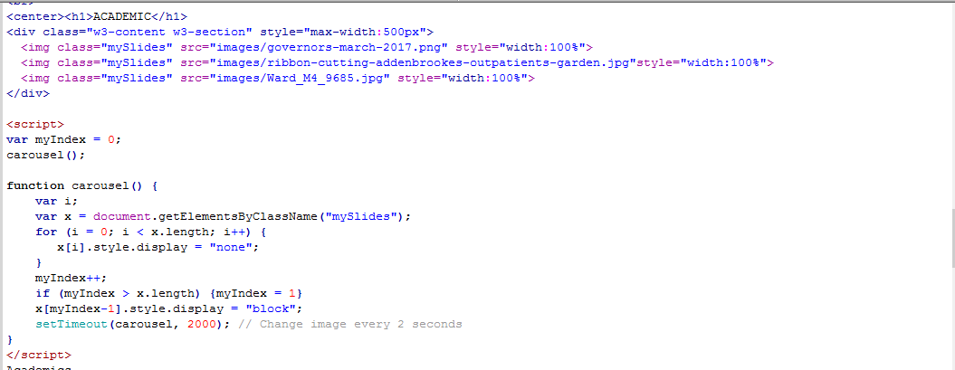

**Task Sheet**

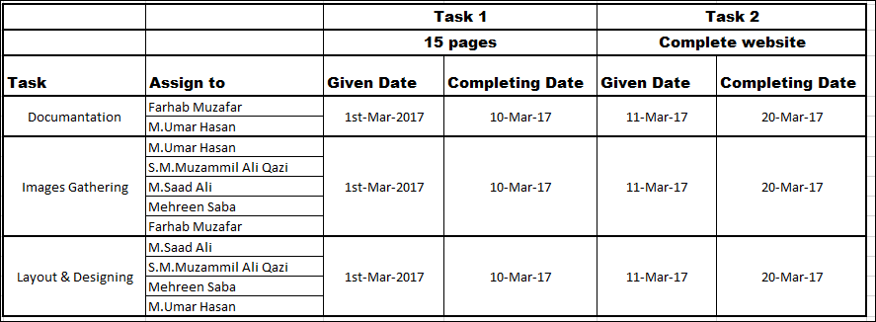

**FLOW CHART**

**PLANNING**

My group member is planning is very simple 1st step create a layout and 2nd step create a logo and 3rd step collect an information and the next step codding. This web site very easily create because its planning is very simple and the most important team work MASHA ALLAH may group member very is intelligent in the most benefit of ALLAH and the next benefit of my group member I am humbly thanks full to all INSHA ALLAH this website successfully completed by the grace of Almighty ALLAH.